Official league roster - Soccer
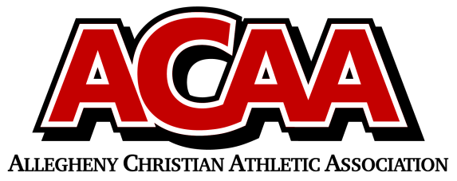

School Name: Johnstown Christian School
Team Colors: Royal Blue and white
Overall Wins ___ Losses ____ Ties ___
ACAA Wins ___ Losses ____ Ties ___ OPPONENT: __________________________
Date: _________
Number | Name | Year | Position | Homeschool
7 | Allison Burkey | 11 | m/d | no
13 | Dakota Wilson-Boyles | 11 | d | no
6 | Unity Miller | 11 | g | no
12 | Sarah Blough | 11 | d/m | no
17 | Riely Unger | 11 | f/m/d | no
9 | Lydia Hostetter | 10 | m | no
15 | Clara Harper | 10 | d | no
14 | Sybella Mack | 10 | f/m/d | no
19 | Olivia Lushko | 10 | f/m/d | no
10 | Ellie Speigle | 10 | m | no
18 | Hope Ressler | 9 | m/d | no
5 | Lily Lushko | 8 | m/d | no
4 | Avah Evans | 8 | f/m/d | no
2 | Noelle Lushko | 7 | f/m | no
11 | Dani Coleman | 7 | m/d | no
16 | Bella Williams | 7 | d/g | no
3 | Isabella Pelesky | 7 | f/m/d | no
8 | Oriana Yoder | 7 | f/m/d | no

Head Coach: David Sprankle
Asst. coach: Jo Habacker
Asst. coach:

Official ACAA League Team Roster. to be submitted to the scorer’s table before each game.

